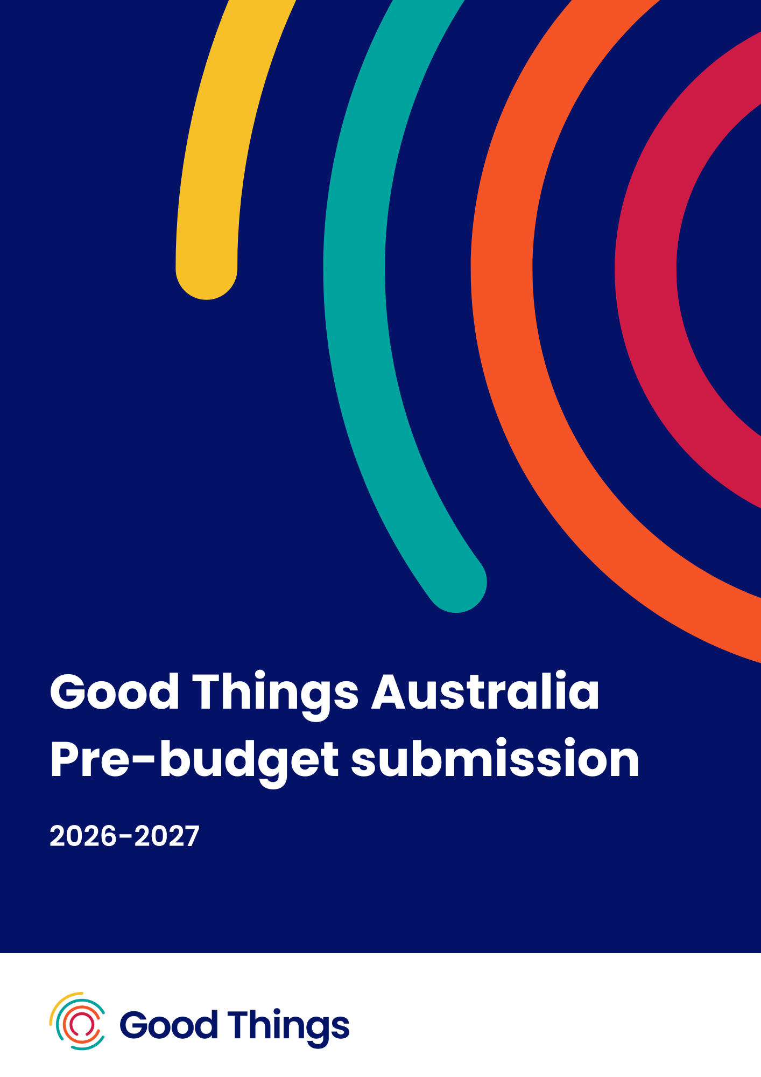

2026-27 Pre-budget submission
Good Things Australia, January 2026

Contents
Overview 3
Detailed recommendations 5
1. Digital inclusion initiatives to strengthen social connection, cohesion and wellbeing 5
1a. Digital Sisters program continuation 5
1b. Digital Champions program continuation 9
2. Digital inclusion programs as a foundation for safe and equitable AI adoption 13
2a. AI literacy and skills programs 13
3. Commonwealth leadership and coordinated investment to close the digital divide 16
3a. Equitable access to connectivity, devices and data 16
3b. A national approach to digital inclusion 19
Related sector submissions 21
About Good Things Australia 21

Overview
Digital inclusion is a critical enabler of Commonwealth priorities, supporting workforce participation and productivity, advancing equity and inclusion, improving access to and efficiency of service delivery, strengthening community wellbeing, and promoting the safe and responsible adoption of technology.
It is a requirement for full participation in our digital society and economy, enabling people to access essential government, education, social and health services. And yet, 1 in 5 Australians are digitally excluded.
Economic modelling shows that investment in digital inclusion programs for highly excluded cohorts would see a benefit of at least half a billion dollars per year.
Ensuring everyone has essential digital skills and access isn’t just about creating a more inclusive society, it also makes good economic sense.

With rapidly changing technology, including the rise of AI, it is imperative to support those more likely to be left behind in order to create a resilient digital economy and society. The Australian Digital Inclusion Index found that digital exclusion mirrors and reinforces other forms of disadvantage. Rates of digital inclusion are significantly lower in one parent households and low income households, among income support recipients, older people, people with disability, First Nations people, people in regional Australia and with lower levels of education.
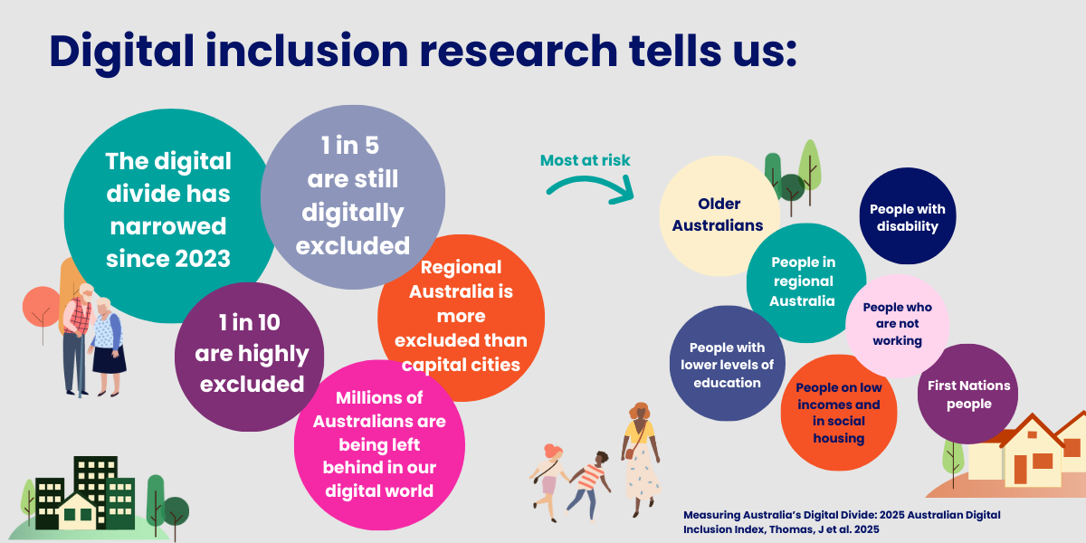
Digital inclusion interventions create tangible impact. The Australian Government’s Be Connected program for over 50s has a Social Return on Investment of $4 for every $1 spent. Meanwhile, the digital ability of older Australians has noticeably improved.
While Australia’s digital divide has narrowed, there are still millions missing out.
As a national digital inclusion leader working alongside government, industry, and community, Good Things Australia’s key recommendations for the 2026–27 Commonwealth Budget cover 3 key areas:
- Digital inclusion to strengthen social connection, cohesion and wellbeing
  - Continue funding the Digital Sisters program to support migrant and refugee women to build digital skills, confidence and social connection.
  - Continue funding the Digital Champions program to enable people with intellectual disability to participate safely and confidently in digital society.
- Digital inclusion as a foundation for safe and equitable AI adoption
  - Support AI skills, literacy and capability building programs to ensure all Australians can understand, safely use and engage with AI-enabled systems and services, and that the rapid adoption of AI and new technologies does not further exacerbate digital exclusion.
- Commonwealth leadership and coordinated investment to close the digital divide
  - Support equitable access to connectivity, devices and data through a National Device Bank and a Tech Reuse for Good Charter.
  - Appoint a Minister for Digital Inclusion and deliver a national strategy to embed digital inclusion across government policy, programs and service delivery.
Good Things Australia thanks the Australian Government for the opportunity to make this submission to the 2026-27 Federal Budget. We would be pleased to discuss our proposed initiatives and recommendations with you, so that together we can close the digital divide for good.

Detailed recommendations

1. Digital inclusion initiatives to strengthen social connection, cohesion and wellbeing

1a. Digital Sisters program continuation
“The Digital Sisters program is a powerful example of what happens when connection, learning and community led change come together to create meaningful and lasting impact – especially for migrant and refugee women who are building new lives in Australia. Some are already established professionals contributing to the Australian workforce, while others are navigating language barriers and the challenges of finding employment. Every single one of them brings incredible resilience, strength, and potential.”
Digital Sisters Digital Mentor
Digital Sisters is a proven, community led digital inclusion program supporting migrant and refugee women to build essential digital skills, confidence, and social connection in trusted, culturally safe settings. Delivered through 55 community organisations nationwide, the program has supported over 5,000 women to participate more independently in Australia’s digital society, strengthening social connection, community cohesion and wellbeing while achieving strong outcomes in digital skills, everyday independence, and AI literacy.
Demand for the program significantly exceeds current capacity, and time limited funding arrangements ending in June 2026 risk undermining momentum, workforce capability, and long term outcomes for women and communities. Continued Commonwealth investment is required to sustain and scale this highly effective program.
Digital Sisters has been recognised by the United Nations Development Programme for its innovative, place based approach to digital inclusion. The program is designed in partnership with community organisations and delivered by trained, bilingual Digital Mentors who work alongside women in their communities. This trusted delivery model is critical for supporting women who face compounding barriers related to language, literacy, settlement experience and access to tailored digital support, and plays an important role in strengthening participation, belonging and social cohesion within diverse communities.

Evidence of need
Women from culturally and linguistically diverse (CALD) backgrounds are more likely to experience barriers to accessing digital services or the internet than the general Australian population.

Good Things Australia’s Australian Attitudes to Getting Online consumer research shows that:
- 1 in 3 CALD women find the variety of technology overwhelming.
- More than half of CALD women are worried that scams are becoming harder to spot.
- 27% of CALD women say they need help to keep up with rapid tech changes.
- CALD women are more likely to struggle to use AI apps, tools and government services.
Additional studies have found that:
- Refugee women living in Australia are more likely to have greater barriers to accessing online services (eg government) due to a combination of low digital skills, confidence and English language proficiency.
- Refugee women without children are more likely to experience lower digital access and usage than women with children aged under 18 years.
- Refugee women were more likely to rely on help from others, such as their children, for digital skills support and access to services.
- Digital ability for refugee and migrant women is a nuanced area, impacted by factors such as age, language and country of origin, requiring highly tailorable digital support programs.
Community organisations provide essential digital inclusion support and are at the frontline of tech support, but are not funded appropriately to do this work. Digital Sisters addresses this gap by enabling community organisations with small grant funding and support to deliver tailored, culturally appropriate digital learning, while also creating safe spaces that reduce isolation, build confidence and strengthen community cohesion.

Outcomes to date
The program has delivered strong, measurable outcomes that extend beyond digital skills alone. Refugee and migrant women in this program have demonstrated positive outcomes across social and economic participation, with participants reporting that:
- 87% have increased their digital skills.
- 70% have increased their everyday independence.
- 70% have increased their social connections.
- 82% have increased their AI knowledge.
These outcomes have been achieved at a cost of just $140 per participant supported, demonstrating exceptional value for money. However, this does not fully cover the costs required to deliver inclusive, high quality programs in line with the Department of Social Services’ Not for Profit Sector Development Blueprint.

Funding context and delivery gaps
Current funding from the Department of Social Services concludes in June 2026, but there remain many women who would benefit from entering the program, as well as women already participating who require ongoing learning as digital services, AI tools and online risks continue to evolve.
Digital Sisters largely reaches cohorts not supported through existing SETS funding, as it is delivered in informal community settings and often supports women who have been settled in Australia for many years and fall outside existing settlement program eligibility.
Community partners consistently report that limited funding constrains their ability to meet demand for ongoing, tailored support, including one to one mentoring, language support, culturally appropriate resources and practical enablers such as interpreters and childcare. Partners also identify that complex, non user friendly online reporting systems create an administrative burden that diverts time away from frontline delivery and limits meaningful data collection.
Over time, Good Things Australia has secured small, time limited corporate support from partners including Microsoft, Telstra and the TPG Telecom Foundation to supplement the Digital Sisters program. This support has enabled innovation, including the development of parenting resources and AI literacy pilots with a small number of community partners. While valuable, these partnerships do not fund core program delivery at scale or provide the certainty required to sustain a national program.

Recommendation and funding request
Continue Commonwealth funding for the Digital Sisters program beyond June 2026 to sustain and expand this national, community led digital inclusion initiative supporting migrant and refugee women.
Funding of $1.5 million per year over three years ($4.5 million total) is sought to deliver the Digital Sisters program, focused on culturally safe digital skills development, strengthening social connection and community cohesion, improving access to government services and workforce participation, and building essential digital confidence.

What this investment will deliver
This investment will enable:
- Community organisations to deliver deeper, higher quality support, enabling 55 trusted organisations to provide culturally safe, place based digital inclusion programs reaching 5,000 migrant and refugee women each year.
- Migrant and refugee women to participate more fully in digital life, building the skills, confidence and safety needed to access services, engage in work and training, and navigate AI-enabled systems.
- A stronger, more sustainable community workforce, with bilingual Digital Mentors supported through coordinated networks, shared learning and professional development.
- Programs that remain relevant as technology changes, through ongoing development of culturally appropriate learning resources aligned to emerging needs and policy priorities.
- Clear evidence of impact and accountability, through fit for purpose monitoring and evaluation that supports learning while minimising administrative burden.

Case study
Ester was a participant in Brisbane based Arise Women Support Association’s first Digital Sisters: AI for Good class. Within minutes, she says, she could see “a new future” on her mobile screen.
“It was amazing, learning how to use Google Translate and online searches – and then Rosemary [the mentor] took me straight into the NDIS portal,” she says. “I could see the plan for my daughter, where the money was going… suddenly it all made sense.”
Ester is just one of thousands of women who have taken part in Good Things Australia’s Digital Sisters and AI for Good programs, supporting migrant and refugee women to keep up with tech. In addition to improving their essential digital skills through these community based programs, outcomes included finding work and being better able to support their kids online. The programs show that digital inclusion benefits for parents and families extend beyond tech, with 80% participants increasing their everyday independence and 78% more socially connected thanks to the support they received though Good Things’ network of committed, local community organisations.
Watch full story

1b. Digital Champions program continuation
"I feel proud that I have a good job. I love the learning and experiences I’ve had. I feel I can teach others, and I love technology even more. I have met new people and made friends."
Digital Champions participant
Digital Champions is a national digital inclusion and leadership program that places people with intellectual disability at the centre of digital inclusion efforts as leaders, educators and change makers. Delivered by Good Things Australia in partnership with Down Syndrome Australia, Digital Champions recognises people with disability as experts in their own lives.
Participants are employed, trained and supported to build their digital skills, access digital technologies safely and confidently, and to educate peers and organisations about how best to support people with intellectual disability to be digitally included and equally benefit from the digital world.

Evidence of need
The Australian Digital Inclusion Index indicates that people with disability are more likely to be digitally excluded. There is a gap of 11.4 points between people with disability and people without, with affordability and access pressures working alongside a greater divide in uptake and usage of emerging tech: GenAI.
Almost three quarters (73%) of people with disability don’t feel comfortable keeping up with changes in technology and the internet, with 38% needing help to keep up with rapid changes in technology. People with disability have also been found to have:
- Lower use of technology and social media
- Lower interest in new technology.
- More experiences of cyberbullying and digital abuse (particularly women).
Good Things Australia’s work with people with intellectual disability highlights additional barriers to full economic and social participation. These include limited understanding among families, supporters and parts of the disability sector about how people with intellectual disability can be supported to be safe and confident online. There is also a lack of accessible, engaging digital skills and online safety resources designed for diverse learning needs.
The Digital Champions program directly addresses this gap by ensuring people with lived experience are leading learning, influencing practice and shaping a more inclusive digital world.

Outcomes to date
The Digital Champions program has delivered strong outcomes for participants and for the broader digital ecosystem. These include:
- Increased employment outcomes, with 90% of Digital Champions progressing to further paid work as a result of their role.
- Increased online safety skills and confidence to use technology, including supporting others to develop these skills.
- Increased leadership, advocacy and employability skills, including presenting and facilitating training sessions and meetings.
- Upskilled society with over 800 people across community, technology, government and social sectors educated on practical approaches to digital inclusion for people with intellectual disability. This includes presenting at high profile events such as SXSW Sydney 2025.
There is growing demand for Digital Champions to speak at events, contribute to organisational training and engage with government, industry and community stakeholders. These opportunities create strong impact but require coordination, preparation and support to ensure participation is meaningful and sustainable.
Learnings from the first year of delivery show that supporting people with intellectual disability to lead national digital inclusion efforts requires more time and resourcing than initially anticipated. Recruitment, onboarding and ongoing support take longer and must be delivered at a person centred pace. Additional time is also required to prepare and support Digital Champions to participate safely and confidently in speaking engagements, training and organisational education.
In addition, the program requires further investment in specialised, accessible learning content and more tailored approaches to gathering feedback and insights from participants. This is essential to effective evaluation, continuous improvement and accountability, and requires flexible, inclusive methods that reflect diverse communication and learning needs.

Funding context
Current funding for the Digital Champions program is provided by the Department of Social Services Information, Linkages and Capacity Building program and is time limited, concluding in June 2026.
The program aligns strongly with the intent of Foundational Supports (community based, preventative digital inclusion support outside individual NDIS plans), presenting an opportunity for a more sustainable funding home within the Department of Health, Disability and Ageing.
Good Things Australia is also partnering with google.org and disability support providers to complement the program with innovative initiatives and resources, but these partnerships do not cover core delivery costs.
Continued Commonwealth investment beyond June 2026 is necessary to prevent the loss of capability, workforce, and momentum built through the successful Digital Champions program.

Recommendation and funding request
Continue Commonwealth funding for the Digital Champions program beyond June 2026 to sustain and expand this national digital inclusion and leadership initiative for people with intellectual disability.
Funding of $500,000 per year over three years ($1.5 million total) is sought to deliver the Digital Champions program, aligned to Foundational Supports, and focused on leadership, accessibility, rights and equal participation in digital life.

What this investment will deliver
This investment will enable Good Things Australia to:
- Support 30 new Digital Champions (10 per year), alongside existing participants, to lead digital inclusion education, advocacy and systems change through lived experience leadership.
- Establish an ongoing Digital Champions alumni program to enable peer mentoring and continued learning, building a national cohort of 50 or more people with intellectual disability as digital literacy experts and advocates.
- Respond to growing demand for speaking, training and engagement opportunities, matching Digital Champions with relevant community, government and industry audiences.
- Develop and maintain specialised, accessible learning content, co designed with people with intellectual disability and responsive to emerging technologies and policy priorities.
- Implement fit for purpose evaluation and learning approaches that reflect lived experience and diverse communication needs, strengthening accountability and continuous improvement.

Case study
“I like to show the world who I am. I am unique and strong, passionate. As a Digital Champion, I like to show that it does not matter if you have disability or not, you can make your dream come true.” Jerry, Digital Champion
Digital Champions teach people how to close the digital divide for people with intellectual disability. Drawing on their own experiences as people with intellectual disability, and supported by Good Things Australia and Down Syndrome Australia, they have inspired hundreds of people to take action through community, conference and stakeholder presentations so far.
In October 2025, Digital Champions Chris and Jerry shared their message at SXSW Sydney, a global festival for changemakers with thousands of attendees.
“I want to learn more about the use of technology and also show my experiences, and I can motivate other people so that they feel more confident using digital technology. So that they are confident being safe and also, more importantly, make them feel happy.” Chris, Digital Champion.
Watch full story

2. Digital inclusion programs as a foundation for safe and equitable AI adoption

2a. AI literacy and skills programs
1 in 3 Australians are worried about what AI will mean for them, and 25% say that they need support to keep up with rapid changes in technology.
Artificial Intelligence (AI) is rapidly reshaping how Australians access information, services, work opportunities and social connection. While AI has the potential to build productivity and capability, it also presents new risks if it is not developed, deployed and used responsibly, ethically and inclusively. Without deliberate action, AI risks exacerbating existing inequalities and widening the digital divide.
Digital inclusion is increasingly recognised as foundational to equitable AI adoption. The Australian Government’s National AI Plan highlights the importance of spreading the benefits of AI across the community and investing in skills, capability and readiness to support responsible adoption. Embedding digital inclusion into AI policy and implementation is critical to ensuring AI systems and services do not entrench disadvantage or create new barriers to participation.
Good Things Australia is already supporting this agenda through community led digital inclusion programs and cross sector partnerships. The AI for Good initiative was recognised in the National AI Plan as a best practice example of partnership, demonstrating how government, industry and the community sector can work together to build AI literacy among people most at risk of digital exclusion. Delivered in partnership with Microsoft, Telstra and LinkedIn, the program supports community members to understand AI, build confidence using AI enabled tools, and engage safely with emerging technologies in trusted, place based settings.
Building on this work, Good Things Australia in partnership with the National AI Centre will develop an economic and social impact report on the AI for Good initiative. This work will strengthen the evidence base on the role of community based AI literacy programs to inform future government policy and implementation.
Not for profit organisations play a critical role in supporting people most at risk of digital exclusion, but the sector itself faces capability challenges as technology evolves. Without targeted support, not for profits will struggle to adopt AI safely, efficiently and ethically and support those they serve to do the same.
Place based digital inclusion initiatives, such as the Australian Government’s Be Connected program, delivered by Good Things Australia in partnership with eSafety and the Department of Social Services, provide a proven pathway to build digital skills and confidence among older Australians. Expanding this model to reach all people experiencing digital exclusion, with a focus on AI literacy and emerging technologies, would offer a practical mechanism to translate national AI policy into real world outcomes.

Recommendation
Embedding digital inclusion into AI policy and practice is essential to ensuring Australia’s AI future is safe, inclusive and trusted.
To ensure AI adoption in Australia is safe, equitable and benefits all Australians, the Commonwealth Government should:
- Embed digital inclusion as a core principle of AI policy and implementation, ensuring AI systems, services and programs do not exacerbate existing disadvantage or exclusion.
- Extend existing digital inclusion programs, such as Be Connected, to additional cohorts, applying established place based approaches to AI and emerging technology skills so all Australians can engage safely and confidently with AI enabled systems and services.
- Partner with Good Things Australia and the community sector to design and scale AI literacy initiatives that translate national AI policy into community level capability.

Case study
“Every Australian should be able to benefit from AI, regardless of age, location or gender. Achieving this outcome requires a broad approach to building capability across all workplaces, including in not-for-profits, universities, schools, TAFEs and community organisations. It must elevate suburban and regional voices and ensure that local businesses and communities are not left behind.”
Australian Government National AI Plan
Good Things Australia, in partnership with Telstra, Microsoft and LinkedIn, has established 10 community based AI Literacy Hubs as the next phase of its AI for Good work, expanding access to AI literacy for people and communities most at risk of digital exclusion.
The hubs are being delivered through a diverse mix of community organisations and combine in person support from Digital Mentors with dedicated, practical, and accessible online AI learning resources. AI literacy content is being integrated into existing national digital literacy programs, with a focus on building confidence to use AI tools in everyday life, learning and pathways to work.
Participating hub organisations have welcomed the program for its practical, community led approach to AI literacy and its potential to strengthen digital skills, media literacy, critical thinking and confidence with emerging technologies. There is growing demand from their communities for trusted, accessible support to understand AI, use it safely, and engage with digital systems that increasingly shape everyday life, work and access to services.

3. Commonwealth leadership and coordinated investment to close the digital divide

3a. Equitable access to connectivity, devices and data
Governments of all levels around Australia are delivering increasingly digitised services. Yet those most likely to need social service supports are least likely to have the skills or the income to access internet services.

Support for a National Device Bank
Affordable access to devices and data is essential to ensuring all Australians are digitally included. Good Things Australia’s research shows that cost of living increases have impacted 1 in 2 Australians' ability to get online, with 1 in 6 people having to make difficult choices about paying for the internet and phone bills versus other essentials like food and housing. Further, the Australian Digital Inclusion Index reveals that 1 in 4 people on the lowest incomes in Australia are having to compromise on internet speed or data to afford the internet.
For many, a lack of a suitable device is a key barrier to getting online. Over 1.16 million school students lack a suitable device, while businesses and governments retire 3 million devices annually, generating 500,000 tonnes of e-waste; two thirds of which ends up in landfill.
In 2025, Good Things Australia and Work Ventures launched the National Device Bank offering a practical, scalable solution: a coordinated system to collect, refurbish, and redistribute technology to Australians in need. This solution reduces e-waste, promotes a circular economy, and ensures equitable digital access. Proven models in Canada and the UK National Device Bank show this works.
However, without government and corporate support this initiative is unlikely to reach its full potential and scale to the levels required to substantively address the issue.
With appropriate support, the National Device Bank will:
- Refurbish and redistribute donated devices from corporate and government sources.
- Create IT traineeships for young Australians.
- Leverage 6,000+ community organisations for national reach.
- Pair device access with digital skills support and affordable connectivity.

Support for a Tech Reuse for Good Charter
An Australian Tech Reuse for Good Charter, led by the Commonwealth Government in partnership with corporate Australia and the for purpose sector and would provide a practical mechanism for government to embed responsible device reuse into standard ICT procurement and asset management practices.
Modelled on the UK’s IT Reuse for Good Charter, it would establish clear principles and guidance for public and private sector organisations to securely wipe, refurbish and donate surplus technology for social good. This would support more consistent and coordinated device donation practices across government and industry, while strengthening confidence in data security, governance, and quality assurance.
Government support for a national Charter would reinforce Commonwealth priorities around digital inclusion, sustainability, and efficient use of public resources. By promoting a reuse-first approach to technology, the Charter would help normalise circular economy practices, reduce e-waste, and increase the availability of devices for trusted community delivery partners. Endorsing and supporting an Australian Tech Reuse for Good Charter would demonstrate national leadership, align with international best practice, and provide an enabling framework to ensure surplus technology delivers maximum social, environmental, and economic value.

Recommendation and funding request
Co-fund the National Device Bank alongside industry partners to ensure all Australians have access to affordable digital devices:
- Champion government support for a National Device Bank and invest $3.2 million per annum for three years to co-fund the initiative.
- Mandate for purpose reuse of retired government technology and introduce tax incentives for corporate device donations.
- Establish an Australian Tech Reuse for Good Charter, encouraging corporates to support the National Device Bank with donated technology.

Case study
“Digital inclusion is a multifaceted challenge and interfaces across all areas of social and economic disadvantage”.
Australian Digital Inclusion Alliance
Across the country, 1 in 5 people are digitally excluded, with low income families, seniors, First Nations communities, and individuals living with disabilities being most affected. As a result, almost 4 million Australians, including over 1.4 million students, lack the devices necessary to access the technology that is essential for work, study, healthcare, and civic participation.
At the same time, Australian companies and governments refresh ~3m computers, tablets and mobiles every year with a very small proportion of this being repurposed for social benefit. Australia generates over 500,000 tonnes of e-waste each year, almost three times the global average per capita. This is predicted to increase to 657,000 tonnes by 2030. Two thirds of this ends up in landfill, unfortunately much of which may be serviceable technology.
The National Device Bank offers a tangible, cost effective mechanism to reduce waste, build inclusion, and strengthen Australia’s circular economy. By connecting environmental and social goals, it delivers measurable outcomes across e-waste reduction, emissions savings and digital equity, all central to Government values and leadership.

3b. A national approach to digital inclusion
To close the digital divide and create a stronger, more inclusive and sustainable digital economy, digital inclusion must be embedded into policy, government systems and processes, with clear ownership and funding. The Australian Digital Inclusion Alliance’s position paper calling for a National Approach to Digital Inclusion sets out the case for accountability and coordination at a national level.
In addition, a National Digital Inclusion Strategy, led by a new Minister for Digital Inclusion, will ensure no one is left behind. This should sit alongside strategies for digital transformation of government services, the First Nations Digital Inclusion Strategy, the National AI Plan, and given the significant economic benefits of closing the digital divide, be considered by the Economic Inclusion Advisory Group. The Strategy would follow the lead of several States, such as the NSW Government’s Digital Inclusion Strategy. The fully funded Strategy must provide a common set of goals for all levels of government to plan, support and fund digital inclusion initiatives in a coordinated manner across departments, led by the Minister responsible. To be effective, the National Digital Inclusion Strategy must be developed and implemented in consultation with federal and state governments, corporate and community sectors, and those at risk of digital exclusion.

Case study
In 2023 the UK Government’s Department for Science, Innovation and Technology (DSIT) established a dedicated digital inclusion portfolio. In the UK, clear ministerial responsibility and a central policy unit have enabled a coordinated, whole of government response to digital exclusion, aligning skills, access, service design and technology reuse under a single framework.
In 2025, DSIT published a Digital Inclusion Action Plan: First Steps, the UK’s first coordinated national strategy on digital inclusion. The plan sets out immediate actions and a longer term framework to address digital exclusion, including support for skills development, tackling data and device poverty, improving access to digital services, and building confidence and local delivery. A Digital Inclusion and Skills Unit within DSIT is leading this work, supported by a cross government ministerial group and an expert advisory committee to drive implementation.

Recommendation
Appoint a Minister for Digital Inclusion and deliver a national strategy to embed digital inclusion across government policy, programs and service delivery:
- Establish a dedicated digital inclusion portfolio within government and appoint a Minister for Digital Inclusion.
- Implement an Australian government led national digital inclusion strategy and with cross government support, so all Australians benefit from a coordinated approach.

Related sector submissions
Good Things Australia endorses and has contributed to the following digital inclusion related pre-Budget submissions to Treasury:
- National Device Bank
- Australian Digital Inclusion Alliance
- ACOSS
Good Things recommends that this submission be considered alongside these complementary sector submissions.

About Good Things Australia
Good Things Australia are future focused digital inclusion leaders, advocating, partnering, educating and innovating to ensure no one is left behind in the digital world. We believe good things happen when everyone is safely, confidently and affordably online. We work to close the digital divide so no one is left behind.
We develop and deliver a range of innovative digital inclusion programs to support those most in need, including people over 50 years of age, people with intellectual disability, migrant and refugee women, and low income families.
We partner and collaborate with other social impact organisations, industry and government to provide holistic, sustainable and impactful digital inclusion programs and to advocate to close the digital divide.
We are active members of the Low Income Digital Inclusion Forum and Australian Digital Inclusion Alliance, collaborators in the ARC Linkage Project: Advancing Digital Inclusion in Low-income Australian Families, and proud co-founders of the National Device Bank.
Learn more about our work at goodthingsaustralia.org.

Contact us
Jess Wilson
CEO, Good Things Australia
jess.wilson@goodthings.org.au
Gadigal Country, Level 3, 223 Liverpool St, Darlinghurst, NSW 2010

Acknowledgement of Country
Good Things Australia acknowledges the traditional custodians of the land and pay respect to Elders past and present. We are committed to listening to the voices of Aboriginal and Torres Strait Islander peoples and support action towards healing and reconciliation.

Australian attitudes to getting online 2024, Good Things Australia, 2024
Economic Benefits of Overcoming Digital Exclusion, Good Things Australia, 2024
Measuring Australia’s Digital Divide, Australian Digital Inclusion Index, 2025
Measuring Australia’s Digital Divide, Australian Digital Inclusion Index, 2025
Economic Benefits of Overcoming Digital Exclusion, Good Things Australia, 2024
Australian attitudes to getting online 2024, Good Things Australia, 2024
Measuring Australia’s Digital Divide, Australian Digital Inclusion Index, 2025
Improving the digital inclusion of older Australians: The social impact of Be Connected, Social Innovation Research Institute and the Centre for Social Impact, 2020
Measuring Australia’s Digital Divide, Australian Digital Inclusion Index, 2025
Digital Inclusion Playbook 2.0: From Access to Empowerment in a Dynamic World , United Nations Development Programme, 2024
Supporting the digital inclusion of new refugees and migrants, Good Things Australia & Settlement Council of Australia, 2020
Australian Attitudes to Getting Online 2025, Good Things Australia, 2025
‘Life would have been harder, harder and more in chaos, if there wasn’t internet’: digital inclusion among newly arrived refugees in Australia during the COVID-19 pandemic, Baganz, E., McMahon, T., Khorana, S., Magee, L., & Culos, I., Communication Research and Practice, 11(1), 24–43. 2025.
The low-income families digital divide: digital inclusion is everybody’s business Digital Media Research Centre, 2024
Not for Profit Sector Development Blueprint, Department of Social Services 2024
Measuring Australia’s Digital Divide, Australian Digital Inclusion Index, 2025
Australian attitudes to getting online 2024, Good Things Australia, 2024
Adult Media Literacy in Australia: Attitudes, Experiences and Needs, Notley, T Chambers, S Park, S Dezuanni, M, WSU, QUT and University of Canberra, 2021
Protecting voices at risk online, eSafety Commissioner, 2020
National AI Plan, Australian Government, Department of Industry, Science and Resources, 2024
Digital divide: 1.16 million students lack home devices, Third Sector, Saplagio A, 2025

