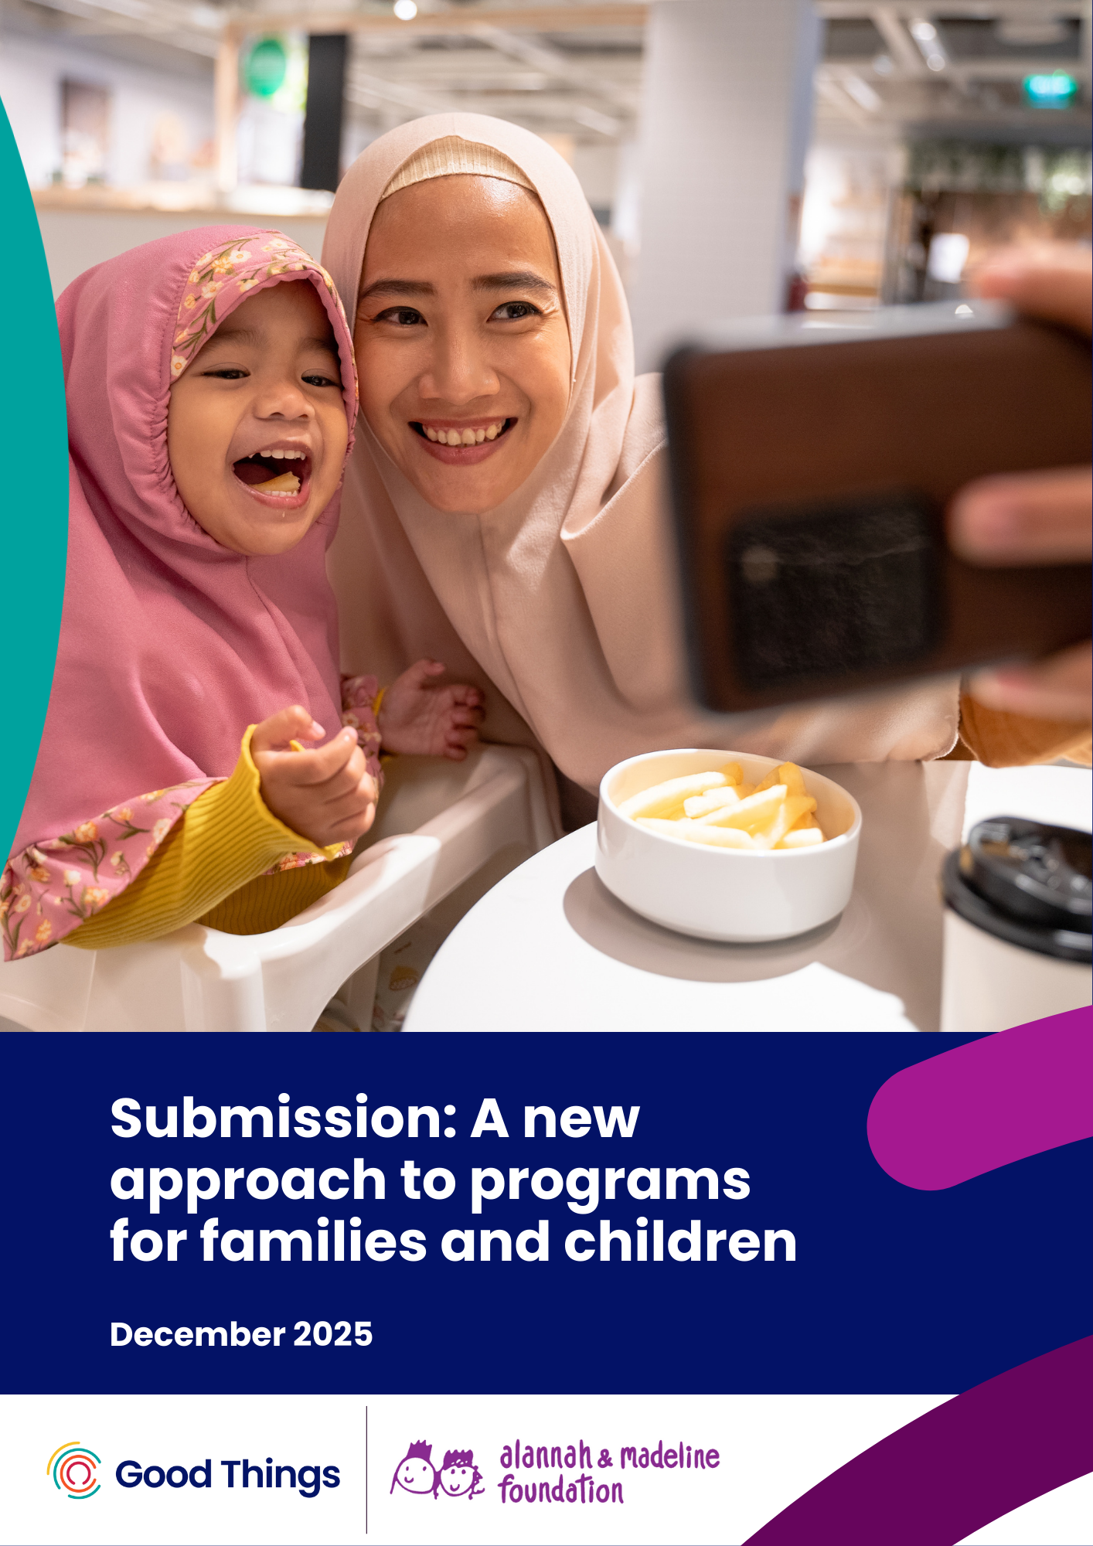

Contents
Introduction 2
Recommendations 2
Evidence to support this recommendation 4
Case study: eSmart Program 6
Case study: Digital Sisters Program 6
Contact us 7
About us 8
About Good Things Australia 8
About Alannah & Madeline Foundation 8
Acknowledgement of Country 8

Introduction
Good Things Australia and the Alannah & Madeline Foundation welcome the opportunity to provide input into proposed reforms to bring together five programs for children, young people and families in order to contribute to two key outcomes: parents and caregivers are empowered to raise healthy, resilient children, and children are supported to grow into healthy, resilient adults.
Priorities for reform include ensuring services are informed by, and respond to, community needs, and investing early to improve family wellbeing and break cycles of disadvantage.
The new program will focus on "practical activities that give parents and caregivers the tools, knowledge and confidence to raise healthy, resilient children", with a particular focus on families at risk of child protection involvement.
In today’s digital world, safe and equitable access to technology (digital inclusion and resilience) for all parents, children and families is essential.
Our submission responds to the following questions in the discussion paper:
- "Are there any other priorities or issues you think the department should be focussing on?"
- "Beyond locational disadvantage, what other factors should the department consider to make sure funding reflects the needs of communities?"

Recommendations
Good Things Australia and the Alannah & Madeline Foundation recommend that the proposed new approach should include a strong focus on digital inclusion, including appropriate digital literacy support and affordable access for parents and caregivers, to boost online safety, participation and resilience.
Digital technologies are embedded in the lives of Australian children and their families, being essential to education, work, play and social connections. However, 1 in 5 Australians are digitally excluded. There are risks in the online world and increasingly rapid tech changes (including AI) that families and children need to be prepared for in order to be digitally resilient.
It is therefore crucial to support digital inclusion interventions that address the needs of children and families, especially in communities with high levels of digital exclusion ie communities with low levels of digital ability, access and affordability.
Lifting digital ability and affordable access for children, parents and caregivers, including among the most vulnerable families, is a valuable preventative measure in reducing online harms, while boosting participation in education, social and economic opportunities. This is recognised, for example, in the National Action Plan to End Gender Based Violence, which cites building digital literacy among children and young people as a key commitment in the prevention space to strengthen positive, equal and respectful relationships. While the education system has a role to play in this space, community based interventions for parents and caregivers are valuable in ensuring they can appropriately support their children to be safe, confident and resilient online. Such interventions are powerful beyond building tech skills, with 80% of participants in Good Things’ community-based Digital Sisters program for younger women increasing their everyday independence. Economically, closing the digital divide and boosting participation could generate half a billion dollars in benefits per annum to the Australian economy.
It is equally important to build the capacity and capability of relevant service providers to enable this support of families, and appropriately fund community organisations to act as front line digital inclusion support. This is in line with the Not For Profit Sector Development Blueprint’s priority commitments to advance digital inclusion, capability and transformation in the not for profit sector and funding the full costs of sector activities.
Good Things and the Alannah & Madeline Foundation recommend that:
- Digital inclusion is treated as a core service under the new funding arrangements, is appropriately funded, and is embedded in programs to boost digital literacies, reduce online harms and build resilience. This may include:
  - Digital skills education for children, parents, grandparents and carers
  - Affordable access to internet connections and devices
- Capability building of service providers in digital inclusion is supported and funded under the new arrangements. This may include:
  - Access to digital mentor training
  - Access to ongoing professional development to keep up with tech changes (eg social media bans, AI evolution and usage, tech facilitated abuse, changes to digital government services, data privacy).

Evidence to support this recommendation
The Australian Digital Inclusion Index found that digital exclusion mirrors and reinforces other forms of disadvantage. Rates of digital inclusion are significantly lower in one parent households and low income households and among income support recipients.
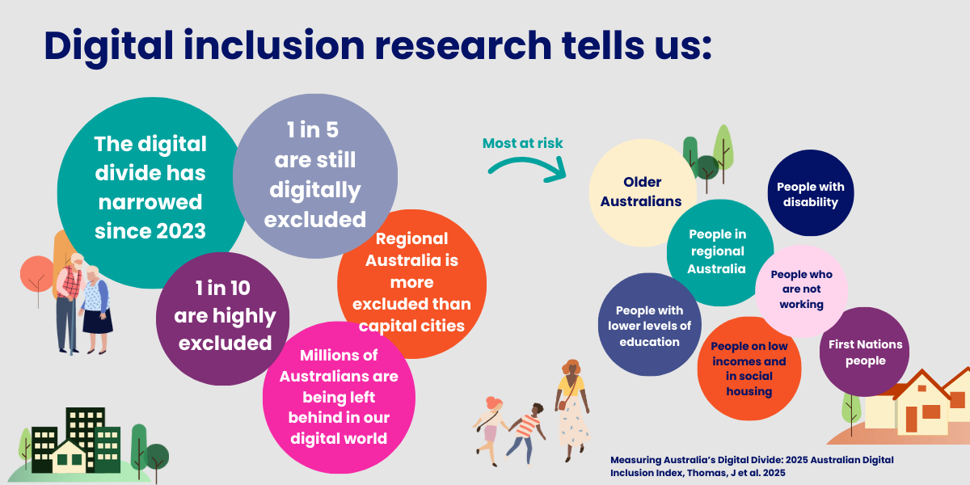
A recent survey conducted for the Alannah & Madeline Foundation of over 1,000 Australian families with children of primary school age found that:
- Use of digital devices was very common from an early age - for example, among Prep / Foundation students, 84% used tablets, 45% used smartphones (their own or someone else's), 34% used gaming consoles, and 34% used laptops.
- Levels of digital literacy among parents and caregivers varied widely.
- Many parents would likely benefit from better support. For example, one quarter of parents agreed "I try to set limits on my primary school aged child's usage of technology and the online world, but I struggle to enforce them", and 90% of parents were classed as either “worried but uninformed” or “disengaged” from the issue of how handling of children’s data is regulated online.
- Government agencies were parents' most trusted source of information about children's online data privacy, with 65% of parents trusting government agencies to help inform them in this space.
While any child may encounter harm online, the risks are much higher for children who are very vulnerable offline. These findings may resonate with the needs of many families supported through the FaC program. For example:
- Teens in out-of-home care and young carers are much more likely than their less vulnerable peers to have experienced online harms including bullying, scams, extreme content, stalking, and dysregulated device use.
- Teens with special education needs and/or mental health concerns are much more likely than their peers to engage with risky forms of AI such as deepfakes and ‘companion’ apps.
- Teens disengaged from study or work are more likely than their peers to be victims of ‘sextortion’ scams.
- Secondary students from low SES backgrounds, regional areas, and/or First Nations families are at higher risk than their peers of certain forms of anxious or dysregulated device use.
- First Nations students and those from low SES backgrounds are more likely to say that distraction by digital devices is a problem in their classrooms.
- Sexting and cyber bullying perpetration are much more common among children who report troubled dynamics with their parents and caregivers.
Additionally, a recent survey conducted by Good Things Australia found that parents, grandparents and carers are at particular risk of being left behind as technology rapidly changes:
- Over 30% of people who are aged over 55 years, are grandparents, or are carers, find the variety of technology available to be overwhelming, with higher rates among culturally and linguistically diverse (CALD) communities.
- 43% of grandparents are unsure how to tell AI generated content from real content.
- One in three parents are concerned about how their children use technology and whether they are safe online.
- Almost half of all respondents (48%) said they are worried that scams are becoming harder to identify. This concern was particularly high among grandparents, especially those from CALD backgrounds (62%) and grandparents aged 55–64 (63%) and women across a range of ages and backgrounds.
- 20% of parents and 23% of grandparents said they need help to keep up with technology.
The ARC Linkage Project on increasing digital inclusion in low income Australian families builds on this knowledge base, finding that:
- Cost of living and affordability is a key barrier for low income families, seeing them make hard decisions between digital connections and other essentials like groceries, often taking on more work or sacrificing their own digital use, putting additional strain on the family.
- Affordable digital access boosts educational participation and outcomes, transition to work and participation in mandated government programs.
- Parents’ and caregivers' digital literacy, attitudes, understanding of risks and online harms, and their own usage of technology and digital media impacts their children’s opportunities and experiences.
- Community organisations provide essential digital inclusion support to families and are at the front line of tech support, but are not funded appropriately to do this work. They report the persistent impact of many agencies (including government) not understanding the barrier digital exclusion places on family participation in programs and access to essential services, and the additional burden this places on community organisations to fill the gap.
Further evidence shows that embedding digital literacy into community based supports, combined with effective, funded support for community organisations offering these services and high quality online learning materials, produces effective outcomes in building essential digital skills, online safety and social connections. Swinburne University’s evaluation of the Be Connected digital skills program for older adults that operates under this model showed a 4:1 social return on investment for every dollar spent on the program.
From this, it can be seen that evidence based digital inclusion initiatives with high quality evaluation can make a positive difference in this space. Further targeted work is needed to:
- build the skills and knowledge of parents and caregivers as well as children, with a particular focus on vulnerable families, and
- appropriate funding arrangements covering this activity is provided to the community organisations already well placed to support these groups.

Case study: eSmart Program
The Alannah & Madeline Foundation is proud of the role played in school communities by our suite of eSmart interventions. These include our eSmart Digital Licence+, an interactive online learning tool that helps build digital intelligence for students aged 10-14. An evaluation by the Australian Council for Educational Research found positive indicators of welcome change. For example, by the end of the module on cyber bullying there was a statistically significant increase in students' disagreement that revenge was an appropriate response to being treated unkindly online, and by the end of the modules on regulating tech use there was a statistically significant increase in students' agreement that managing one's screen time can be beneficial.

Case study: Digital Sisters Program
Ester was a participant in Brisbane-based Arise Women Support Association’s first Digital Sisters: AI for Good class. Within minutes, she says, she could see “a new future” on her mobile screen.
“It was amazing, learning how to use Google Translate and online searches – and then Rosemary [the mentor] took me straight into the NDIS portal,” she says. “I could see the plan for my daughter, where the money was going… suddenly it all made sense.”
Ester is just one of thousands of women who have taken part in Good Things’ Digital Sisters and AI for Good programs, supporting migrant and refugee women to keep up with tech. In addition to improving their essential digital skills through these community based programs, outcomes included finding work and being better able to support their kids online. The programs show that digital inclusion benefits for parents and families extend beyond tech, with 80% participants increasing their everyday independence and 78% more socially connected thanks to the support they received though Good Things’ network of committed, local community organisations.

Contact us
Good Things Australia and the Alannah & Madeline Foundation thank DSS for the opportunity to provide this submission and would welcome a meeting to discuss our recommendations.
Jess Wilson
CEO, Good Things Australia
jess.wilson@goodthings.org.au
Gadigal Country, Level 3, 223 Liverpool St, Darlinghurst, NSW 2010
goodthingsaustralia.org
Sarah Davies AM
CEO, Alannah & Madeline Foundation
sarah.davies@amf.org.au
Ground Floor, 387 City Road, South Melbourne, Vic 3205
alannahandmadeline.org.au

About us

About Good Things Australia
Good Things Australia are future focused digital inclusion leaders, advocating, partnering, educating and innovating to ensure no one is left behind in the digital world. We believe good things happen when everyone is safely, confidently and affordably online. We work to close the digital divide so no one is left behind.
We develop and deliver a range of innovative digital inclusion programs to support those most in need, including people over 50 years of age, people with intellectual disability, migrant and refugee women, and low income families.
We are active members of the Low Income Digital Inclusion Forum and Australian Digital Inclusion Alliance, collaborators in the ARC Linkage Project: Advancing Digital Inclusion in Low-income Australian Families, and co-founders of the National Device Bank.

About Alannah & Madeline Foundation
As a leading national not-for-profit charity dedicated to keeping children and young people free from violence and trauma, the Alannah & Madeline Foundation supports young Australians to recover and heal from trauma and empowers them to become positive digital citizens.
Our eSmart Program offers learning tools and resources, aligned to the curriculum and free for all Australian schools, to help students build online safety and digital and media literacy skills and behaviours to thrive online. We also advocate for children’s rights in legislation, regulation, systems and policy, notably in the digital environment.
Our vision is that all children and young people are safe and inspired with the freedom to flourish.

Acknowledgement of Country
Good Things Australia and the Alannah & Madeline Foundation acknowledge the traditional custodians of the land and pay respect to Elders past and present. We are committed to listening to the voices of Aboriginal and Torres Strait Islander peoples and support action towards healing and reconciliation.

Digital Inclusion is Everybody's Business: Key findings from the ARC Linkage Project Advancing digital inclusion in low-income Australian families, Digital Media Research Centre, Queensland University of Technology, 2023
Australian Digital Inclusion Index, ARC Centre of Excellence for Automated Decision-Making and Society, RMIT University, Swinburne University of Technology,and Telstra 2025
National Action Plan to End Gender Based Violence, Australian Government, 2022
Australian Digital Inclusion Index, 2025
'Refuge and Risk: life online for vulnerable young people, The Cybersurvey (Youthworks), 2020
The new face of digital abuse, Internet Matters 2024;'Me, Myself and AI research, Internet Matters, 2025
Sexual extortion of Australian adolescents, Australian Institute of Criminology, 2025
Reporting Australia's result, vol.2, Programme for International Student Assessment (PISA), 2024
Reporting Australia's result, 2024
Vicarious Supervision & Role of Parents in Preventing Bullying and Cyberbullying Cyberbullying Research Centre, 2022
Australian Attitudes to Getting Online 2025: Report, Good Things, 2025
Digital inclusion is everybody's business, 2024
Economic Benefits of Overcoming Digital Exclusion, Nicki Hutley & Good Things, 2024
Not for Profit Sector Development Blueprint, Australian Government Department of Social Services, 2024
Improving the digital inclusion of older Australians, Swinburne University, 2021

