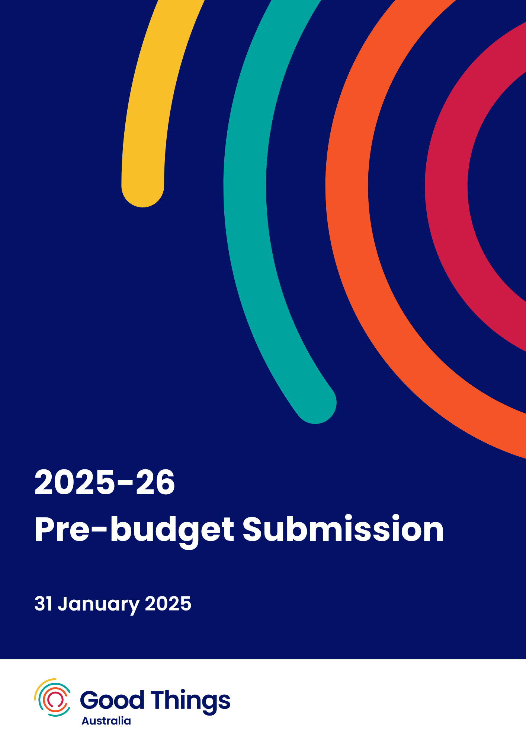

# Contents

**Contents 2**

**Executive summary 3**

**Introduction 4**

**Fund digital inclusion programs for priority groups 5**

Digital Sisters program expansion 5

Supporting people with intellectual disability 6

Recommendations 6

**Affordable digital access 7**

National Device Bank 7

Affordable connections and data 8

Recommendations 8

**Keeping up with AI, emerging tech and cyber security 8**

Recommendations 9

**National strategy on digital inclusion 10**

Recommendation 10

**Additional submission details 10**

**About Good Things Australia 11**

Contact us 11

Acknowledgement of Country 11

# 

# Executive summary

Digital inclusion is a requirement for full participation in our digital society and economy, enabling people to access essential government, education, social and health services. And yet, 1 in 4 Australians are digitally excluded.[1]

Economic modelling shows that investment in digital inclusion programs for highly excluded cohorts would see a benefit of at least half a billion dollars per year.[2]

To close the digital divide and realise these benefits, Good Things’ key recommendations for inclusion in the 2025-26 Federal Budget are:

1. Fund digital skills programs for priority groups at greater risk of being left behind.
2. Invest in initiatives to ensure all Australians have access to affordable digital devices and data so they can fully participate in the digital world.
3. Invest in initiatives to help people keep up with emerging technology, cybersecurity and AI, to support people to keep improving their digital skills and navigate new technologies.
4. Fund the creation and implementation of a government-led national digital inclusion strategy so all Australians benefit from a coordinated approach.

Good Things Australia thanks The Treasury for the opportunity to provide this submission and welcomes the opportunity to meet with you to discuss our recommendations.

Contact:

Jessica Wilson  
CEO, Good Things Australia   
e: jessica.wilson@goodthingsfoundation.org  
p: (02) 9051 9292

# 

# Introduction

One in four Australians are digitally excluded[3] and 59% do not feel comfortable keeping up with tech changes.[4]

This means they are at risk of being left behind in accessing online government services, confidently avoiding scams, protecting their children from online safety hazards, and connecting with work, the online economy and their community.

Closing the digital divide does not just create positive social impact. It makes economic sense.

A conservative estimate of the economic impact of closing the digital divide shows that there are almost half a billion dollars in annual benefits available if appropriate digital inclusion training and financial support are delivered.[5]

To close the digital divide, Good Things’ key recommendations for the 2025-26 Federal Budget cover four key areas:

1. Fund digital skills programs for priority groups at greater risk of being left behind.
2. Invest in initiatives to ensure all Australians have access to affordable digital devices and data so they can fully participate in the digital world.
3. Invest in initiatives to help people keep up with emerging technology, cybersecurity and AI, to support people to keep improving their digital skills and navigate new technologies.
4. Fund the creation and implementation of a government-led national digital inclusion strategy so all Australians benefit from a coordinated approach.

Good Things Australia thanks the Australian Government for the opportunity to make this submission to the 2025-26 Federal Budget.

We would be pleased to discuss our proposed initiatives and recommendations with you, so that together we can close the digital divide for good.

# Fund digital inclusion programs for priority groups

In the 2024-25 budget, the Australian Government committed $42 million funding to extend the national [Be Connected](https://beconnected.esafety.gov.au/) digital skills program for over 50s, through to 2028. This was good news for Australian seniors, giving them continued access to local essential digital skills support in their community.

But, it is not just older Australians who need this support. People with low levels of education, people with disability, First Nations people, new migrants and refugees, and low income families are also at risk of being left behind in our digitised world.[6]

We recommend that the Government fund tailored, community-based digital skills programs focused on two priority groups: refugee and migrant women, and people with intellectual disability.

## Digital Sisters program expansion

Over the past 18 months, Good Things has worked with 55 community organisations, located across Australia, to co-design and deliver digital literacy support to refugee and migrant women. Through the UNDP recognised[7] [Digital Sisters initiative](https://goodthingsaustralia.org/our-programs/digital-sisters/), Good Things provided grants between $10,000-$20,000 to organisations to participate in the program, collated and created learning materials, and trained and supported over 100 bi-lingual digital mentors to deliver digital literacy programs to women in their communities. As a result of this program:

* 95% of women reported feeling more confident using technology
* 71% reported increased online safety
* 91% reported stronger social connections
* 87% reported increased access to digital devices
* 97% of women would recommend the program to others in their community.

Now a proven success, the Digital Sisters initiative is well placed to expand its impact to reach more women across the country with place-based, trusted and effective digital inclusion support.

## Supporting people with intellectual disability

Almost three quarters (73%) of people with disability don’t feel comfortable keeping up with changes in technology and the internet, with 38% needing help to keep up with rapid changes in technology.[8] People with disability have also been found to have:

* Lower use of technology and social media[9]
* Lower interest in new technology[10]
* More experiences of cyberbullying and digital abuse (particularly women).[11]

Good Things’ program initiatives for people with intellectual disability have found several barriers in supporting full economic and social participation, including:

* Lack of awareness and understanding of how people with intellectual disability can best be supported to be safe and confident online amongst both families/ supporters and the disability sector
* Lack of a full range of appropriate and engaging digital upskilling and online safety resources tailored to people with intellectual disability.

[Our programs](https://goodthingsaustralia.org/our-programs/bridge-the-digital-divide-initiative/), delivered in partnership with Down Syndrome Australia, have demonstrated the positive impact that digital inclusion programs and tailored resources can have for people with intellectual disability, but there remains a gap in long term support available on a national scale.

## Recommendations

Fund digital inclusion programs for two priority groups in the 2025-26 Budget:

1. Fund $1.8m pa over 3 years ($5.4m total) to support 100 community organisations to deliver place based digital skills support to 5,000 refugee and migrant women per year, through Good Things’ proven Digital Sisters initiative.
2. Fund $3m pa over 3 years ($9m total) in pre-program codesign and research, and holistic digital inclusion program delivery for people with intellectual disability, including:
   1. Access, affordability and ability measures that improve connectivity and digital literacy for people with intellectual disability
   2. Exploration and recommendations on how the successful approaches can be integrated long term into NDIS package supports
   3. Awareness and community education campaign to build knowledge of supports available and understanding of the positive impact of digital inclusion for people with intellectual disability and their supporters, to overcome barriers to getting online.

# Affordable digital access

Affordable access to devices and data is essential to ensuring all Australians are digitally included. Cost of living increases have impacted 1 in 2 Australians' ability to get online.[12] 1 in 6 people are making difficult choices about paying for the internet and phone bills versus other essentials like food and housing.[13] Some people are more at risk of digital affordability impacting their lives, including First Nations people, young people (18 -44 yr olds), and people with disability.

Solutions to improve the availability of affordable connections, such as low cost broadband and free NBN connections for priority groups, are possible but need Government investment to be implemented.

## National Device Bank

Establishing a National Device Bank will provide refurbished and donated devices, data and training to people in Australia most in need, enabling equitable access to digital opportunities. This critical new piece of social infrastructure would be made possible through the donation of devices due to be decommissioned from corporates and government, extending the life cycle of devices and keeping them in use. The donated devices would be data sanitised, refurbished and staged, before being redeployed nationwide into communities for free. These devices would be distributed via WorkVentures, Good360, and Good Things’ collective network of over 6,000 not for profit and community partners, ensuring they go to people in Australia who need them most. Our sister organisation in the UK has established a National Device Bank, with a model we have learnt from and will localise to the Australian context.

## Affordable connections and data

Good Things endorses the recommendation from the Australian Communications Consumer Action Network (ACCAN) of a concessional broadband service for households receiving Commonwealth financial support.[14] This initiative would deliver eligible households an unlimited 50/20Mbps NBN service at a discounted rate of $30 per month. This initiative would support the digital inclusion of low income households by providing direct cost of living relief.

Additionally, while we welcome the extension of the School Student Broadband Initiative to benefit low income families with school aged children, making this initiative available to additional low income households, including child free homes, would further support cost of living relief for those doing it toughest, while providing opportunities for greater economic and social participation.

## Recommendations

Fund initiatives to ensure all Australians have access to affordable digital devices and data so they can fully participate in the digital world:

1. Invest $3 million ($1m pa over 3 years) in the creation of a National Device Bank, in collaboration with WorkVentures, Good360, and Good Things Australia, seeing 1m devices donated and distributed to people who need them most within 5 years.
2. Invest in low or no cost connectivity initiatives, including:
   1. Implementation of a low cost broadband service for eligible households, delivering an unlimited 50/20Mbps service for $30 per month
   2. Expanding the Australian Government’s School Student Broadband Initiative to enable free NBN connections for other priority groups and people over school age, such as people on income support.

# Keeping up with AI, emerging tech and cyber security

Artificial Intelligence (AI) is an emerging technology that has the potential to support people to build digital skills and confidence and make our lives easier. But, like lots of new technologies, it also has the potential to do harm if not used responsibly or ethically, if it is not developed with inclusion in mind and if it is not used equally across the population.

1 in 3 Australians are worried about what AI will mean for them, and 25% say that they need support to keep up with rapid changes in technology.[15]

With the rapid development of emerging technology like AI, holistic digital skills programs spanning AI Literacy, Media Literacy and Digital Literacy are essential so the digital divide does not increase.[16]

Australian not for profits already support people most at risk of digital exclusion through their service offerings. But, the sector needs additional support to themselves keep up with tech and continue implementing cost-effective, efficient and secure services. Just 1 in 3 are already investing in or exploring how they can use AI in their organisation, and only 1 in 5 organisations have a plan in place to improve their cyber security.[17] In recent sector research, 49% reported that their staff and volunteers are not fully confident in using their organisations’ digital technology, with the biggest barrier for not for profits to build their digital capability being funding and budgets.[18]

## Recommendations

Fund initiatives to help people keep up with emerging technology, cybersecurity and AI, to support people to keep improving their digital skills and navigate new technologies.:

1. Invest $10m pa for 3 years ($30m) on AI Literacy for All programs, with a focus on people most at risk of digital exclusion (co-invested with industry), inclusive of:
   1. Education campaign on AI, its benefits and risks, and support available to learn
   2. Digital upskilling materials and resources creation
   3. Place-based community support for adults of all ages through a network of 500 community partners, including $7.5m pa in grant funding, reaching 10,000 people per year
   4. Additional research on AI and digital inclusion as the new technology emerges and rapidly changes, including on AI and its impact on misinformation/disinformation.
2. Support for not for profits to adopt new and emerging tech and stay secure, including additional funds so the not for profits sector can invest in AI and cybersecurity measures.

# National strategy on digital inclusion

To close the digital divide and create a stronger, more inclusive and sustainable digital economy, digital inclusion must be incorporated into policy as well as funding decisions.

A National Digital Inclusion Strategy will ensure no one is left behind. It should sit alongside strategies for digital transformation of government services and the future of work and, given the significant economic benefits of closing the digital divide[19], be considered by the Economic Inclusion Advisory Group. The Strategy must provide a common set of goals for all levels of government to plan, support and fund digital inclusion initiatives in a coordinated manner. To be effective, the National Digital Inclusion Strategy must be developed and implemented in consultation with federal and state governments, corporate and community sectors, and those at risk of digital exclusion.

## Recommendation

1. Fund the creation and implementation of a government-led national digital inclusion strategy so all Australians benefit from a coordinated approach.

# Additional submission details

Good Things Australia endorses and has contributed to budgetary submissions made to Treasury regarding digital inclusion, in collaboration with:

* [Australia Digital Inclusion Alliance](https://www.digitalinclusion.org.au/)
* [WorkVentures](https://workventures.com.au/)

Good Things proposes that this submission be reviewed in conjunction with these collaborative sector recommendations.

# About Good Things Australia

Good Things Australia are future focused digital inclusion leaders, advocating, partnering, educating and innovating to ensure no one is left behind in the digital world.

We believe good things happen when everyone is safely, confidently and affordably online. We work to close the digital divide so no one is left behind.

We develop and deliver a range of innovative digital inclusion programs to support those most in need, including people over 50 years of age, people with intellectual disability, migrant and refugee women, people with chronic health conditions, carers and low income families.

We partner and collaborate with other social impact organisations, industry and government to provide holistic, sustainable and impactful digital inclusion programs and to advocate to close the digital divide.

Good Things Australia is part of the Good Things Foundation Group, delivering digital inclusion programs in Australia since 2017 and in the UK for over 15 years.

Learn more about our work at [goodthingsaustralia.org](http://goodthingsaustralia.org).

## Contact us

Jessica Wilson  
CEO, Good Things Australia   
**e:** jessica.wilson@goodthingsfoundation.org  
**p:** (02) 9051 9292

[**goodthingsaustralia.org**](http://goodthingsaustralia.org)

Good Things Australia | Gadigal Country, Level 3, 223 Liverpool St, Darlinghurst, NSW 2010

## Acknowledgement of Country

Good Things Australia acknowledges the traditional custodians of the land and pays respect to Elders past and present. We are committed to listening to the voices of Aboriginal and Torres Strait Islander peoples and support action towards healing and reconciliation.

1. [Measuring Australia’s Digital Divide](https://www.digitalinclusionindex.org.au/wp-content/uploads/2023/07/ADII-2023-Summary_FINAL-Remediated.pdf), Australian Digital Inclusion Index, 2023
2. [Economic Benefits of Overcoming Digital Exclusion](https://goodthingsaustralia.org/news/economic-benefits-of-overcoming-digital-exclusion-report), Good Things Australia, 2024
3. [Measuring Australia’s Digital Divide](https://www.digitalinclusionindex.org.au/wp-content/uploads/2023/07/ADII-2023-Summary_FINAL-Remediated.pdf), Australian Digital Inclusion Index, 2023
4. [Australian attitudes to getting online 2024](https://goodthingsaustralia.org/news/australian-attitudes-to-getting-online-2024), Good Things Australia, 2024
5. [Economic Benefits of Overcoming Digital Exclusion](https://goodthingsaustralia.org/news/economic-benefits-of-overcoming-digital-exclusion-report), Good Things Australia, 2024
6. [Measuring Australia’s Digital Divide](https://www.digitalinclusionindex.org.au/wp-content/uploads/2023/07/ADII-2023-Summary_FINAL-Remediated.pdf), Australian Digital Inclusion Index, 2023
7. [Digital Inclusion Playbook 2.0: From Access to Empowerment in a Dynamic World](https://www.undp.org/policy-centre/singapore/publications/digital-inclusion-playbook-20) , United Nations Development Programme, 2024
8. [Australian attitudes to getting online 2024](https://goodthingsaustralia.org/news/australian-attitudes-to-getting-online-2024), Good Things Australia, 2024
9. [Adult Media Literacy in Australia: Attitudes, Experiences and Needs](https://medialiteracy.org.au/wp-content/uploads/2021/04/FINAL_Australian_adult_media_literacy_report_20212.pdf), Notley, T Chambers, S Park, S Dezuanni, M, WSU, QUT and University of Canberra, 2021
10. [Adult Media Literacy in Australia: Attitudes, Experiences and Needs](https://medialiteracy.org.au/wp-content/uploads/2021/04/FINAL_Australian_adult_media_literacy_report_20212.pdf), Notley, T Chambers, S Park, S Dezuanni, M, WSU, QUT and University of Canberra, 2021
11. [Protecting voices at risk online](https://www.esafety.gov.au/diverse-groups/protecting-voices-risk-online), eSafety Commissioner, 2020
12. [Australian attitudes to getting online 2024](https://goodthingsaustralia.org/news/australian-attitudes-to-getting-online-2024), Good Things Australia, 2024
13. [Australian attitudes to getting online 2024](https://goodthingsaustralia.org/news/australian-attitudes-to-getting-online-2024), Good Things Australia, 2024
14. [Pre-Budget Submission 2025-26,](https://accan.org.au/accans-work/submissions/2383-pre-budget-submission-2025-26) ACCAN, 2024
15. [Australian attitudes to getting online 2024](https://goodthingsaustralia.org/news/australian-attitudes-to-getting-online-2024), Good Things Australia, 2024
16. [Digital Sisters AI for Good report: Understanding AI literacy and digital inclusion](https://goodthingsaustralia.org/news/digital-sisters-ai-for-good-report-understanding-ai-literacy-and-digital-inclusion), Good Things Australia, 2024
17. [Digital Technology in the Not-for-Profit Sector Report 2024](https://www.infoxchange.org/au/digital-technology-not-for-profit-sector), Infoxchange, 2024
18. [Digital Technology in the Not-for-Profit Sector Report 2024](https://www.infoxchange.org/au/digital-technology-not-for-profit-sector), Infoxchange, 2024
19. [Economic Benefits of Overcoming Digital Exclusion](https://goodthingsaustralia.org/news/economic-benefits-of-overcoming-digital-exclusion-report), Good Things Australia, 2024