# Session Plan: Intro to online safety

## Delivery mode:

Face to face delivery

## Session overview:

This session will provide learners with practical tips on how to stay safer online.

## Learning objectives:

By the end of this course you will learn

* about the steps you can take to feel safer online
* what to do if you feel unsure about something
* what to do if something goes wrong

## Suggested session length:

This session should run for approximately 2 hours. The facilitator to schedule regular breaks as required.

## Facilitator Tips:

* Each learner must have access to their own device for this session.
* This session is best delivered using a data projector and screen to allow all learners to follow along.
* As some learners may not be confident or able to read, you may be required to read the material out loud. Encourage the learners to follow along using their own device.
* Learners may need headphones if they choose to listen to the online course using the Text to Voice facility.
* Do a test run of the session including the activities and using the videos to ensure you are familiar with the content. Open the videos in separate tabs so they are ready to be shown.
* To adjust the volume, activate closed captions or to slow the speed of Youtube videos refer to the screenshots below.

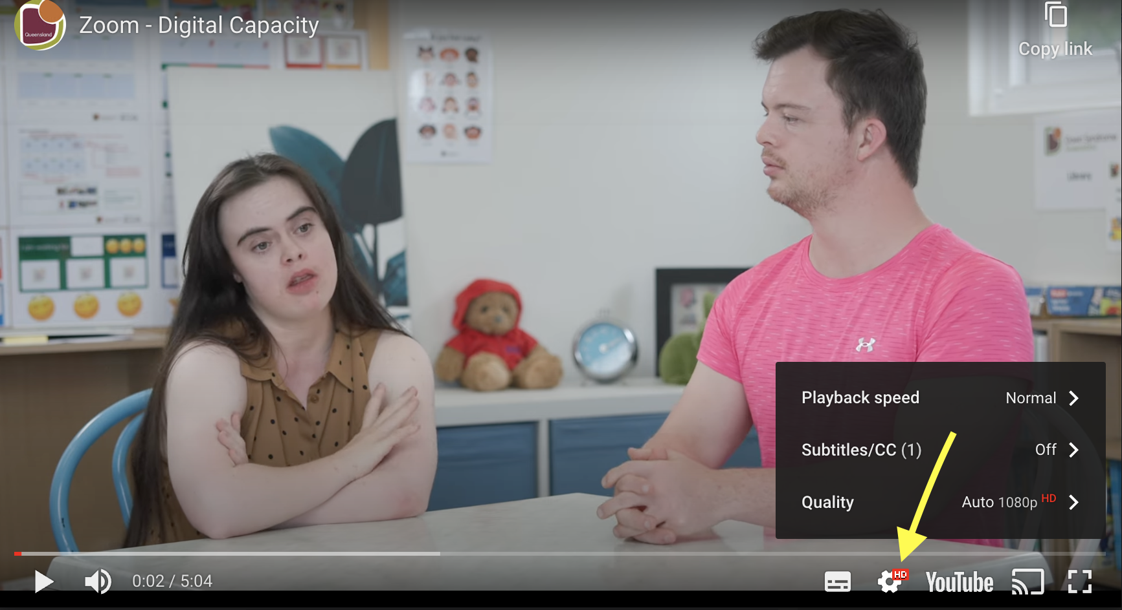 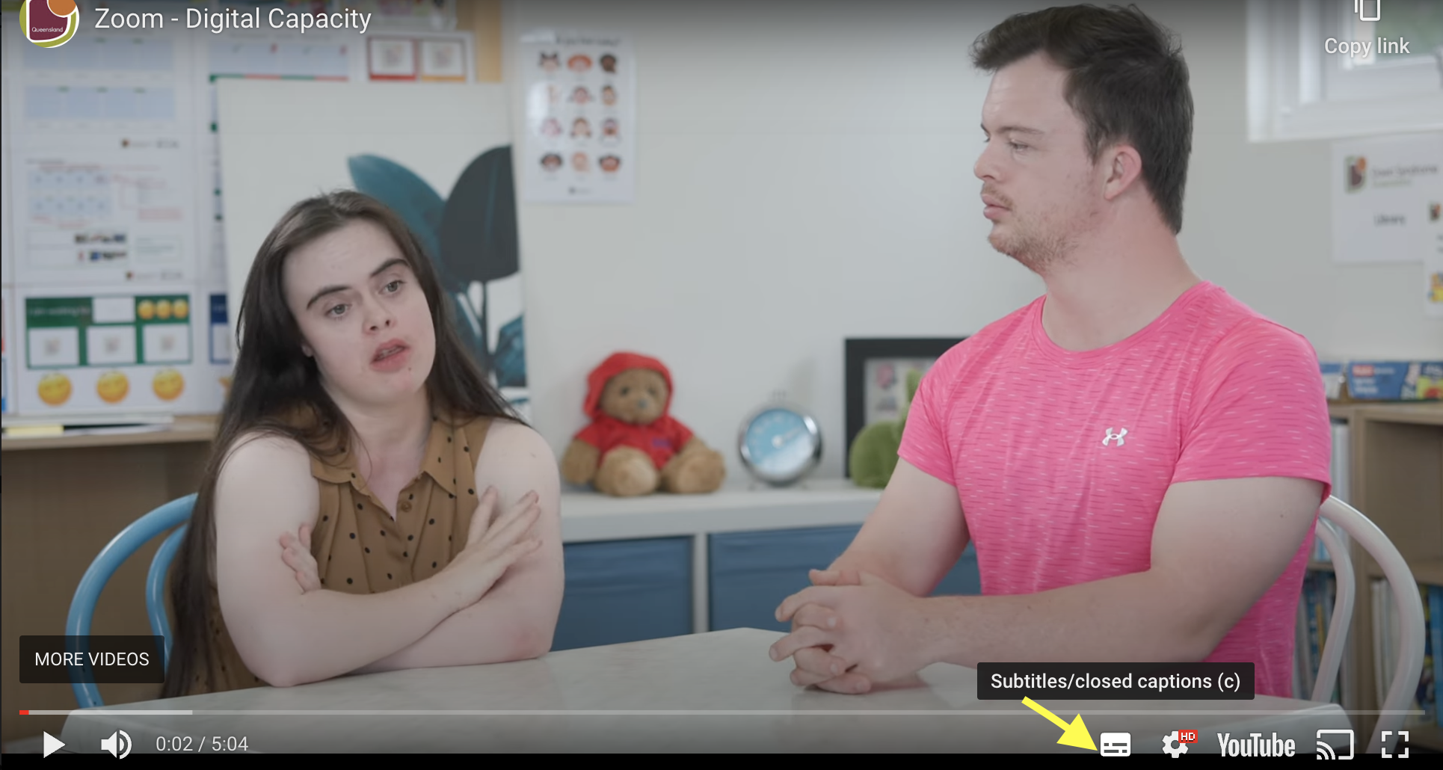

* Pausing videos will allow learners to catch up and provide an opportunity for discussion.

## More courses in this series:

* Connecting with others safely online
* Using emails
* Video calling

| Topic | Timing | Activity | Assessment | Resources |
| --- | --- | --- | --- | --- |
| **Introduction & welcome**  Hi icon | 10 mins | Facilitator to:   * introduce themselves * confirm all learners have their devices set up * remind learners to do as much as they can by themselves * discuss the learning objectives * discuss how the session will run * remind learners to raise their hand to gain facilitator attention.   **Activity 1 - Icebreaker Thumbs Up If**  Learners introduce themselves and facilitator starts the icebreaker activity. Explain there are three ways to answer the ten questions.  The aim is to to provide a fun way for the learners to answer questions about being online. It also provides an insight into the level of digital knowledge and skills held by each learner. | All learners engage | Training venue  Refreshments  Laptop or PC, data projector and screen  Learners to each have access to an internet connected device  [‘Intro to online safety’ online course](https://goodthingsaustralia.org/learn-resource/intro-to-online-safety-online-course/)  Notepads / Pens  Whiteboard / marker pens  [Thumbs Up if icebreaker](https://goodthingsaustralia.org/mentor-resource/icebreaker-exercise-thumbs-up-if/) |
| **Online course**  **Online course icon** | 40 mins | Facilitator to confirm all learners can access the online course - Intro to online safety.  **Activity 2 -** [**‘Intro to online safety’ online course**](https://goodthingsaustralia.org/learn-resource/intro-to-online-safety-online-course/)  Learners to commence the online course and to work their way through the material at their own pace.  Ask the learners to make notes or draw a picture of the key points they wish to discuss after the break.  Remind learners and their support person they can talk to you if they have any questions about the material.  Consider walking round the room asking learners how they are getting on as they may need reassurance or want to ask questions.  Encourage learners to complete the short online module feedback form.  Ask the learners to close the online course once they have finished. | Learners engage at their own pace.  Discussions with support person | [‘Intro to online safety’ online course](https://goodthingsaustralia.org/learn-resource/intro-to-online-safety-online-course/)  Notepad / pen  Links to videos used in online course:   * [How to use this course video](https://youtu.be/gKlm7EuVEgA) * [What should you not share online](https://www.youtube.com/watch?v=ljAO-petDSg) * [Scam emails](https://www.youtube.com/watch?v=kdArOn-G4LM&list=PLrhP4QUd_aXOXk2eygd9Kg4oRCQ92VFrO&index=10) * [Tips to stay safer online](https://www.youtube.com/watch?v=nrMnzRhYi3M)   Feedback form in online course:   * [Intro to online safety evaluation form](https://docs.google.com/forms/d/e/1FAIpQLSfFrvD5G_TZ12C7_D2gzoXGFXtn825VbrsLS2xU-qArtsbfKw/viewform) |
| **Break** | 10 mins | Encourage learners to have a break, stretch their legs and have a drink if needed. |  |  |
| **Discussion & Recap**  **Chat icon** | 15 mins | **Activity 3 - Shared learning with conversation cards**  Facilitator to ask each learner to share 1 -2 things they have learnt from the online course.  Facilitator to ask if the learners noted down any key points they learnt during the online course they wish to discuss now.  Facilitator to recap the following using the relevant conversation starter cards   * Block calls from people you do not know. * Be aware of scam and spam text messages and emails. * How to identify spam and scams. * Never click on links or attachments from spam, scam messages or emails. * Why you should limit the amount of information you share online. * It’s ok to ask for help or talk to a trusted person about being online. | All learners participate. | Laptop , PC, tablet or smartphone  Marker pens  [Conversation starter cards](https://goodthingsaustralia.org/mentor-resource/using-our-conversation-cards/)  [Intro to online safety top tips handout](https://goodthingsaustralia.org/learn-resource/5-tips-to-stay-safer-online/) |
| **Discussion**  **Chat icon** | 15 mins | **Activity 4 - Password Managers**  Facilitator to ask the question - Who uses a password manager?  Facilitator to hold a discussion to check learners understanding of   * What is a password manager app. Examples include 1password, Nordpass, Google password manager. * How they can help to store and remember all of our passwords. * Show the different types of password manager apps available. * Remind learners to check the reviews and costs of password manager apps before buying and installing one. | All learners participate | Links to some common password manager apps:   * <https://1password.com/> * <https://nordpass.com/> * <https://passwords.google/> |
| **DiscussionChat icon** | 10 mins | **Activity 5 - Reflection**  Facilitator to ask learners if they can explain how to recognise a spam or scam text message or email. | Learners all participate |  |
| **Evaluation and closeThumbs up icon** | 10 mins | **Activity 6 - Evaluation form**  Facilitator to ask the learners to complete and return the online / hard copy overall workshop evaluation form. This is different to the feedback form linked to the online module.  Provide learners with certificate of completion to celebrate their success. | Learners all participate | Help us see how useful this workshop was by sharing:   * [Overall workshop evaluation form](https://docs.google.com/forms/d/1b1BY5KgodYwmHkmpNvBpxVIngPozzJmEhMxmdMpx1KI/)   Print and distribute:   * [Certificate of completion (editable)](https://goodthingsaustralia.org/mentor-resource/intro-to-online-safety-certificate-of-completion-editable/) |